**ENHANCEMENT IN CAREER FINDER**

**ABSTRACT:**

The purpose of this project is to enhance a job portal website by adding additional features that will improve the user experience and increase the likelihood of successful job matches. This project has added the features including a personality assessment test for job seekers, a skill-based search function for employer’s usage. This website adds the features for simplifying the process of setting up interviews, for reducing scheduling conflicts and improving the overall efficiency of the virtual hiring process. This website integrates resume builder and blogger functionality. Resume builder feature helps to present job seeker’s qualification and in securing an interview. Blogger helps to share employee’s interview experience and company reviews with the new job seekers. This website integrates the feature of job application tracking systems which helps job seekers to know the application status such as whether application is forwarded to a correct employer or not. Because of these features this website will attract more users and increase its value as a resource for job seekers and employers alike.

**Keywords:** Job portal, Recruiters, Job- Seekers, Fraud, Internet, Internet users

**CHAPTER-1**

**1.1 INTRODUCTION:**

Job portal is an online platform designed to connect job seekers with various industries to provide the suitable employment opportunities. In addition to standard job listing this project has incorporated several additional features. This project offers a comprehensive candidate profile management system that allows job seekers to showcase their qualifications, work experience, education, and other relevant information to potential employers. This feature enables employers to assess candidate suitability quickly and make informed hiring decisions. The feature for monitoring job applications will assist job searchers in keeping track of their applications' status. This technology would provide efficient and organized tracking of job applications at various companies.

**1.2 OVERVIEW:**

There are a number of additional features that may be added to a job portal in addition to its standard capabilities to improve user experience and benefit both employers and job searchers. Applicant tracking system, resume generator, and professional blog creation are a few of these extra features.

**1.3 OBJECTIVES OF THE STUDY:**

1. To study the various recruitment processes.
2. To study various limitations in the existing job portal websites.
3. To study the difficulties faced by job-finder from the point of finding jobs.
4. To study the difficulties faced by employer from the point of providing jobs.

**1.4 MOTIVATION:**

In addition to the basic features of a job portal, there are several additional features that can be incorporated to enhance the user experience and provide value to both job seekers and employers. Some of these additional features include: Application tracking system, Resume builder, creation of blog for professionals.

**CHAPTER-2**

**LITERATURE REVIEW:**

**2.1 The Role of E-Recruitment in Attracting Potential Candidates: Evidence from Fresh Graduate Job Seekers:**

**Rakholiya and Gupta (2013)** studied the applicant's perception toward the usefulness of e-recruitment websites, processing time and cost of e-recruitment, specific factors while selecting a job through e-recruitment. Research methodology was descriptive and analytical: research design was qualitative and quantitative, sample size for this research was taken 100, convenience sampling method was used. This study focused on the e-recruitment on the individual’s perception and satisfaction. On the basis of individual understanding engineering practices provided online job seekers need to deliver valuable information, easy & enjoyable web-based recruitment to job seekers.

# 2.2 Impact of e-recruitment and job-seekers perception on intention to pursue the jobs:

**Khan et al. (2013)** explored the significance of e-recruitment practices and investigated the relationship between the job seekers perception, recruitment sources and intention to pursue the job. 257 respondents were chosen for the study. The present study established that internet is the most popular recruitment source to search the jobs and to study the job seekers perceptions.

**2.3 E-Recruitment: A Conceptual Study. International Journal of Applied Research:**

**Kaur (2015)** focused on the criteria for effective e-recruitment, methods, trends, benefits & drawbacks of the e-recruitment. The research methodology was exploratory and qualitative. Secondary sources of data were taken from various journals, articles, and research papers. The author suggested traditional method should not be replaced by the online recruitment fully, it should supplement and cover the traditional method and recruitment process will be faster and time saving. In the recruitment process adopted by companies the credit goes to the value, efficacy and ease of using career site.

# 2.4 Factors affecting e-recruitment:

**Ahlawat and Sangeeta (2016)** explored the different sources of e-recruitment in the organization like ease of use for the organization, increasing the speed to hire, keeping ahead of competitors, cost savings, to ease of use for candidate, to provide large candidate pool. This study was a set of comprehensive overviews of e-recruitment, also to see the challenges and benefits of using online technologies. The organization used online recruitment system to track and manage candidate’s application, that gives significant benefits in the term of cost and capability, efficiency to monitor on recruitment activities.

**2.5 Effect of E-Recruitment on Recruitment:**

**Malhotra & Sharma (2016)** compared with traditional recruitment process with e-recruitment advantages and disadvantages, changed in recruitment practices and strategies causes of e-recruitment tools and analysed the challenges and opportunities for both organizations and employees using e-recruitment. The study found that traditional method not be replaced by e-recruitment. It should complement. It is a fast process. In the modern time job portals are the most popular source of e-recruitment because commercial websites provide a platform for employers to meet the prospective employees.

**Limitations of existing system:**

There are several limitations of job portal websites, including: Even though job portal websites have a vast database of job postings, they still cannot cover all the job openings available. Sometimes, the job descriptions posted on job portal websites may not accurately reflect the actual job requirements. This can lead to applicants applying for jobs that are not suitable for them or employers receiving applications from candidates who do not have the required skills or experience. Job portal websites rely on algorithms and automation to match job seekers with job openings. This can result in a lack of personal touch, making it difficult for job seekers to connect with potential employers and showcase their skills and experience. This can be a disadvantage for job seekers who prefer a more personal approach to job searching.

**Chapter 3**

**System modelling**

**3.1 DFD level 0 & level 1**

**DFD 0**

A data flow diagram (DFD) maps out the flow of information for any process or system. It uses defined symbols like rectangles, circles and arrows, plus short text labels, to show data inputs, outputs, storage points and the routes between each destination. They can be used to analyse an existing system or model a new one. Like all the best diagrams and charts, a DFD can often visually “say” things that would be hard to explain in words, and they work for both technical and nontechnical audiences, from developer to CEO. The DFD level 0 of this project is discussed in this chapter. DFD Level 0 is also called a Context Diagram. It’s a basic overview of the whole system or process being analysed or modelled.

Employee

Employer

Jobs

**DFD Level 0**

In DFD level 0 shows there is two logins. One is employee login and other is employer login. In employee login, the employee can create his profile and generate resume. Then he can search jobs. He can also search or write blogs. In employer login, the employer can post jobs with description.

**DFD 1**

DFD Level 1 is a general overview, but it goes into more detail than a context diagram or DFD 0. In level 1 DFD, the single process node from the context diagram is broken down into sub-processes. As these processes are added, the diagram will need additional data flows and data stores to link them together.

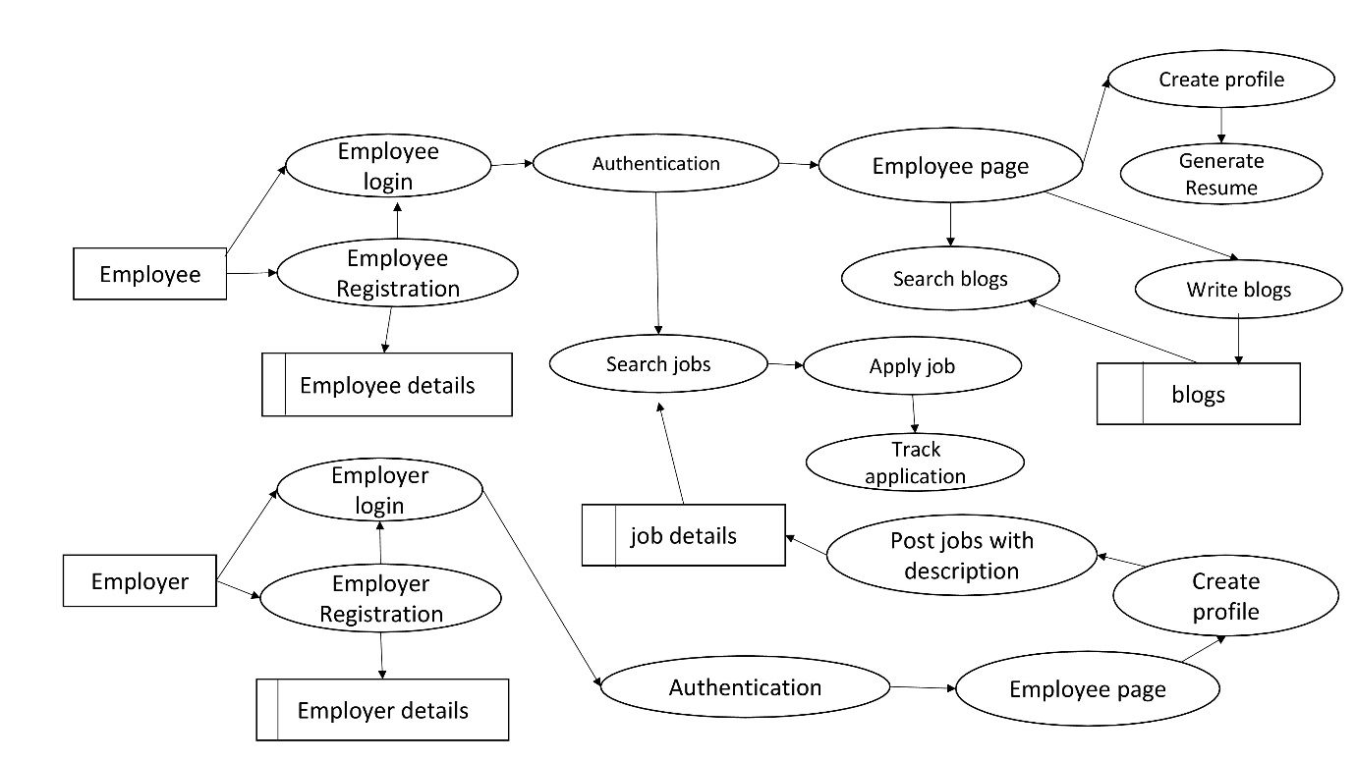

**DFD level 1**

In DFD level 1 shows the detailed view of employer login and employee login. In employee login, the employee should have an account or he should create an account with strong user name and password. The employee login details are stored in database. Before login, system needs to authenticate the valid user or not. In employee page has menu bar. It contains create profile, search jobs, and blogs. After creating the profile, the employee can generate his resume. The employee details are stored in database. The employee can search and apply the job. The employee can track the status of the applied job. In blogs, the employee can search or write the blog. In employer login, the employer should have an account or he should create an account with strong user name and password. The employer login details are stored in database. Before login, system needs to authenticate the valid user or not. The employer page has create profile and post jobs. The employer should his create profile before posting the job. Before posting the job, employer should provide the job description. The job details are stored in database.

**3.2 System architecture**

An architectural diagram is a visual representation that maps out the physical implementation for components of a software system. It shows the general structure of the software system and the associations, limitations, and boundaries between each element.

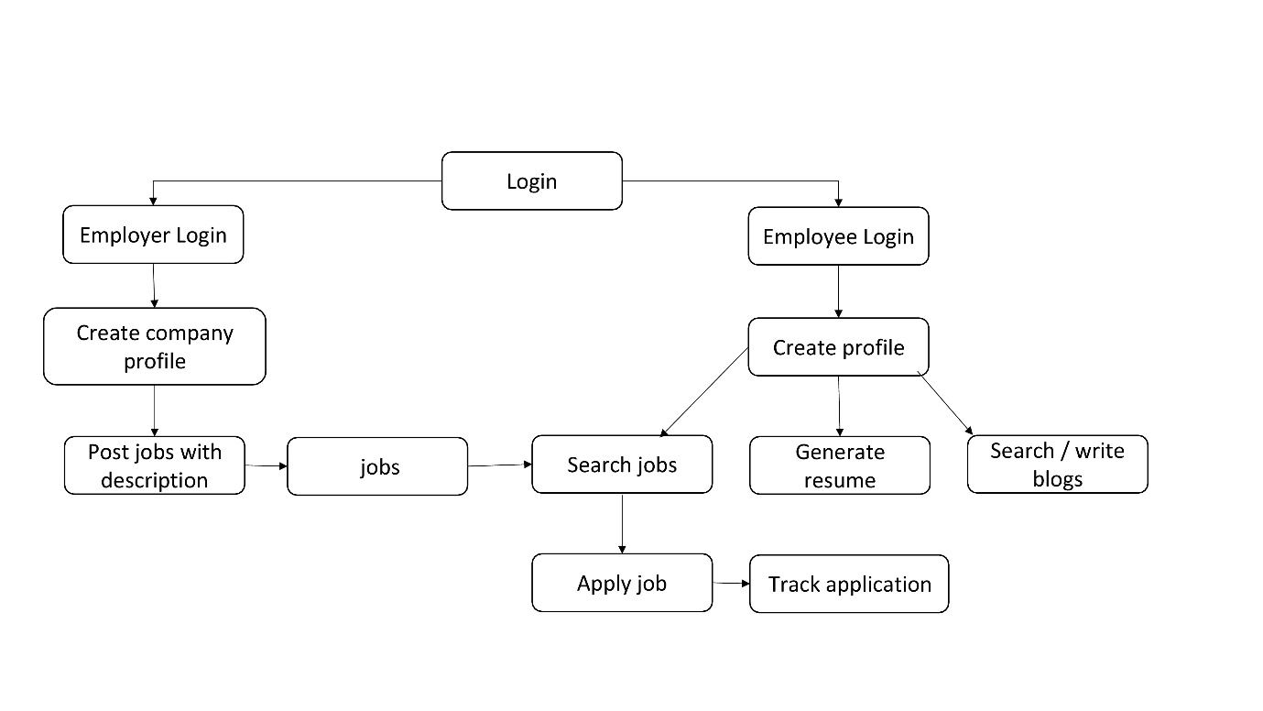

**Architecture diagram**

The diagram shows there is two logins. One is employee login and other is employer login. In employee login, the employee has to create his profile. After creating the profile, he has to search jobs, Search/write blogs and generate his resume. The employee can search apply the job. The employee can track the status of the applied job. In blogs, the employee can search or write the blog. In employer login, the employer should his create profile. Before posting the job, employer should provide the job description.

**3.3 Hardware and Software Specifications**

**Hardware Specification**

The following are the hardware requirement of the system that the design can be implemented upon.

**Minimum Specification:**

* Hard disk space of 512 Megabytes.
* Intel i3 or Ryzen 3 processor.
* RAM of 2 Gigabytes.

**Recommended Specification:**

* Hard disk space 1024 Megabytes or more.
* Intel i5 or Ryzen 5 processor.
* RAM of 4 Gigabytes or more.

**Software Specification**

The following are the software requirement of the system that the design can be implemented upon.

* Operating System Either Windows (or) Linux.
* **Frontend Languages:**

HTML:

The HTML markup language is used to create the structure of the web page.

CSS:

The CSS stylesheets are used to design the web pages

React JS:

The React JS framework is used create components needed in this project.

* **Backend languages:**

Node JS:

In backend, the NODE JS framework is used. Packages like express, axios are used to send request or response and connect the database.

Cloud Database: MongoDB Atlas

MongoDB Atlas is a cloud database used in this project.

**3.4 Contribution**

810020104058-Pooarasu S

**Documentation**

Project documentation is the process of recording the key project details and producing the documents that are required to implement it successfully. The project documentation tool should Be easily editable even by non-technical users, ideally, in real time. **Microsoft word** tool is used to edit and create the document. Its’ is very comfortable to use.

**Application tracking system**

Job application tracking system which helps job seekers to know the application status such as whether application is forwarded to a correct employer or not.

**Backend**

In backend, the NODE JS framework is used. In NODE JS, the middleware functions are used to authentication the login form. Packages like express, axios are used to send request or response and connect the database.

**MongoDB Atlas**

MongoDB Atlas is a cloud database used in this project. The database is accessed by connection string URL.

810020104083-Vigneshwaran V

**Frontend**

**UI/UX**

ReactJS makes it easy to create reusable UI components that can be used across the entire application. This approach saves time and improves consistency in the UI design. ReactJS has a built-in CSS-in-JS solution, but using CSS modules is a better approach for larger applications. React Router is a powerful routing library that makes it easy to navigate between different pages or views within an application. Creating the login system, Employer login page and Employee login page

**Blog**

Deciding on the design and layout of the blog, including font, colors, and formatting. Creating a component for each section of the blog, such as Header, Footer, BlogPost, Sidebar, etc. Implementing a commenting system that allows users to comment on blog posts.

**Resume generator**

Deciding on the design and layout of the resume, including font, colors, and formatting. Installing any additional packages that might need, such as react-router-dom, react-bootstrap, or react-icons. Using CSS or a CSS framework, such as Bootstrap, to create the layout and styling of the resume. Create a download button that generates a PDF of the resume based on the user's information.